

NAME: Leona Kamau
ID NUMBER: 669086
COURSE CODE: DSA3050A
COURSE DESCRIPTION: Business Intelligence and Analysis
Date of Submission: 18/04/2026

Table of Contents
1. Introduction 4
2. Data Acquisition and Understanding 5
2.1 Domain and Business Problem Statement 5
2.2 Dataset Source and Overview 6
2.3 Description of Key Tables and Fields 6
2.4 Sustainability for Advanced Power BI Analysis 7
Evidence for this section 7
3. Data Cleaning and Transformation in Power Query 8
3.1 Data Import 8
3.2 Data Cleaning and Transformation 9
4. Data Modelling 11
4.1 Star Schema Architecture 11
4.2 Relationship Management and Cardinality 13
4.3 Time Intelligence and Optimization 14
5. DAX Measures and Calculated Columns 15
5.1 DAX Measures 15
5.1.1 Total Loan Amount 15
5.1.2 Average Loan Amount 15
5.1.3 Total Borrowers 15
5.1.4 Average Interest Rate 15
5.1.5 Default Rate (%) 15
5.1.6 Approved Loan Rate (%) 16
5.1.7 Average Loan-to-Income Ratio 16
5.1.8 High-Risk Loans Count 16
5.1.9 Loan Ranking by Amount 16
5.2 Calculate Columns 17
5.2.1 Income Band 17
5.2.2 Risk Category 17
6. Dashboard Design and Visualization 18
7. Analytical Insights and Business Recommendations 19
7.1 Analytical Insights 19
7.1.1 High Loan Burden Increases Default Risk 19
7.1.2 Lower Income Borrowers Exhibit Higher Risk 19
7.1.3 Certain Loan Intent Categories Carry Higher Risk 19
7.1.4 Credit History Plays a Key Role in Loan Outcomes 19
7.1.5 Home Ownership is Associated with Lower Default Rates 20
7.1.6 Interest Rates Tend to Be Higher for Riskier Borrowers 20
7.2 Business Recommendations 20
7.2.1 Implement Stricter Controls on High Loan-to-Income Ratios 20
7.2.2 Enhance Risk-Based Pricing Strategies 20
7.2.3 Prioritize Lending to Lower-Risk Segments 20
7.2.4 Improve Credit Assessment Models 21
7.2.5 Offer Financial Education and Support Programs 21

Introduction
This report documents the development of a comprehensive Power BI analytical solution, covering the full process from raw data preparation to the generation of actionable business insights. The primary objective of this project is to build a reproducible and well-structured analytical model that supports real-world decision-making in the banking and financial services sector. The analysis is based on a large-scale loan dataset containing over 45,000 records of loan applicants. The dataset provides detailed information on borrower demographics, financial status, credit history, and loan characteristics, making it suitable for advanced business intelligence analysis.
Throughout this project, several key analytical processes are implemented:
- Data Cleaning and Transformation: Addressing data quality issues such as missing values, duplicate records, and inconsistent formats to ensure accuracy and reliability.
- Data Modelling: Designing and implementing a relational star schema to support efficient querying, improved performance, and scalable reporting.
- Analytical Computing: Developing advanced DAX measures, including performance indicators and risk-related metrics, to enable deeper insights into loan behavior.
- Data Visualization: Creating an interactive three-page Power BI dashboard that supports both executive-level summaries and detailed analytical exploration.
Overall, this project demonstrates how raw financial data can be transformed into meaningful insights that support better decision-making in loan approval, risk management, and customer profiling.

Data Acquisition and Understanding

Domain and Business Problem Statement
This project focuses on Banking and Financial Analytics, specifically in the area of loan risk assessment and customer profiling. Financial institutions rely on data-driven insights to evaluate borrowers, manage credit risk, and improve lending decisions.
The main business problem addressed in this project is how to analyze borrower characteristics and loan attributes in order to identify patterns that influence loan approval and default risk. Understanding these patterns is critical for minimizing financial loans and optimizing lending strategies.
Key analytical questions addressed include:
- Which borrower characteristics are associated with higher default risk?
- How do income levels and loan amounts affect loan approval outcomes?
- What role does credit history play in determining loan status?
- Which segments of customers present the highest risk to lenders?
- How can financial institutions improve their loan approval strategies?
By answering these questions, the Power BI solution provides valuable insights that support better credit risk management and more informed decision-making.

Dataset Source and Overview
The dataset used in this project is a publicly available loan dataset obtained from an online data repository. It contains over 45,000 records of loan applicants and includes both demographic and financial attributes(Loan Approval Classification Dataset, n.d.).
Each record represents an individual loan application and includes variables such as age, gender, income, education, employment experience, loan amount, interest rate, credit history length and loan status.
The dataset reflects real-world financial data and includes a mixture of numerical and categorical variable. It also contains some inconsistencies and missing values, making it suitable for demonstrating data cleaning and transformation techniques in Power BI. The dataset is appropriate for business intelligence analysis as it enables the study of borrower behavior, credit risk, and lending performance.

Description of Key Tables and Fields
The dataset was initially provided as a single flat table containing loan application records. To support efficient analysis and reporting in Power BI, the data was transformed into a structured relational model consisting of fact and dimension tables.
The key tables used in this project are summarized below:
Table Name | Type | Description
Fact_Loans | Fact Table | It contains core loan-related measures such as loan amount, interest rate, and loan status. It serves as the central table for analysis.
Dim_LoanDetails | Dimension | It includes attributes such as loan intent and loan status for categorizing loan types.
Dim_Credit | Dimension | It contains credit-related attributes such as credit score and credit history length.
Dim_HomeOwnership | Dimension | It stores information about the borrower’s home ownership status.

Sustainability for Advanced Power BI Analysis
The selected dataset is highly suitable for advanced Power BI analysis for several reasons:
- Volume of the dataset: This dataset contains a large volume of records which exceeds the minimum requirements and allows for meaningful aggregation and pattern detection.
- Variety of data types: The dataset includes both numerical and categorical variables. Numerical fields such as income, loan amount and interest rate enable quantitative analysis, while categorical variables such as education level, loan intent, and home ownership allow for segmentation and comparison.
- Data Transformation: The dataset contains several data quality issues. These issues provide an opportunity to demonstrate data cleaning and transformation skills using Power Query.
- Advanced Analytical Techniques: The dataset enables the application of advanced analytical techniques such as DAX calculations, segmentation and trend analysis, making it ideal for building a comprehensive and professional Power BI solution.

Evidence for this section
The screenshot will show the first few rows of the dataset:
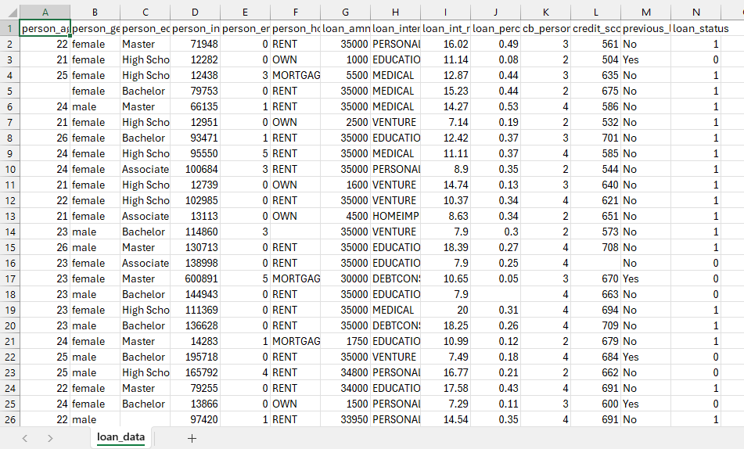

Data Cleaning and Transformation in Power Query

Data Import
The dataset was loaded into Power BI using the “Get Data” feature. Upon loading into Power Query, the dataset was examined to understand its structure, identify data types, and detect potential issues such as missing values, duplicates, and inconsistencies.
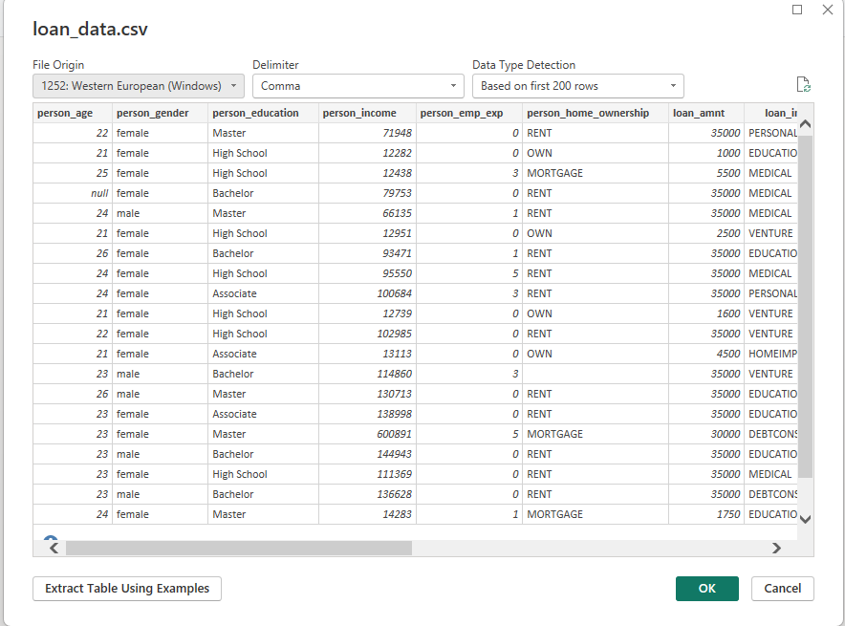

Data Cleaning and Transformation
To ensure the loan dataset was accurate for financial risk modeling, I performed the following transformations:
- Identified null values within the loan_int_rate column. I utilized the "Replace Values" transformation to fill these gaps, ensuring that average interest rate calculations remain mathematically sound.
- Removed currency symbols and percentage characters from the raw text fields. This was a prerequisite for converting these columns into formats suitable for mathematical aggregation.
- Transformed the loan_status column from 0/1 to descriptive terms ("Non-Default" / "Default") to make the final dashboard intuitive for non-technical stakeholders.
- Changed the case for person_gender, loan_intent and person_home_ownership
- Explicitly changed data types for financial metrics to support complex DAX measures.
- Applied Trim and Clean functions to text-based columns such as person_education and loan_intent. This removed trailing spaces and non-printable characters that often cause errors in filtering and slicers.
- I added a new column named "Credit Grade" using IF/THEN logic:
  - If credit_score >= 700, then "Excellent"
  - If credit_score >= 600, then "Fair"
  - Else, "Poor".
- Filtered the person_age and person_income columns to remove unrealistic values (e.g., ages over 100 or negative income) that would skew the risk profile.

Applied Steps
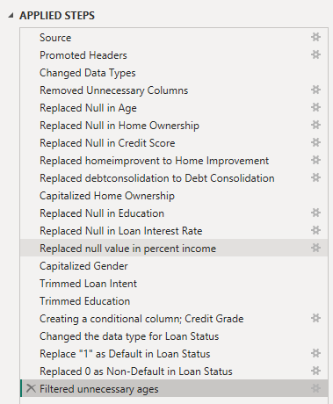
Conditional Column
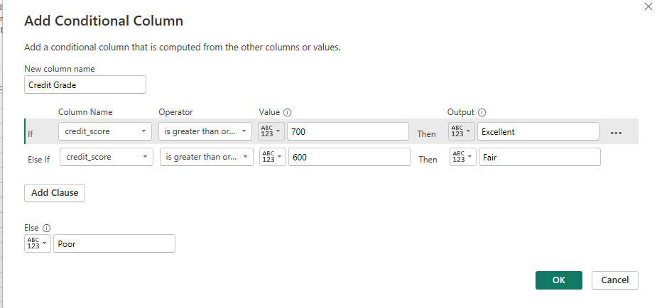

Data Modelling

Star Schema Architecture
The original dataset was provided as a single flat table containing lan application records, without a predefined relational structure. To support efficient and analytical performance in Power BI, the dataset was transformed into a structured data model.
A star schema approach was adopted, where a central fact table stores measurable loan-related data, and surrounding dimension tables provide descriptive attributes for filtering and segmentation. This structure improves query performance, enhances scalability, and simplifies report development.
During the modeling process, the dimension tables were created. Several dimension tables were created to support filtering and categorization:
- Dim_Loan – contains loan-related categories such as loan intent and loan status.
- Dim_HomeOwnership – contains borrower home ownership categories.
- Dim_Credit – contains credit-related attributes such as credit score and credit history length.
An attempt was made to create a borrower dimension table; however, due to the absence of a unique borrower identifier, it was not possible to generate a meaningful and non-redundant dimension. As a result, borrower attributes were retained within the fact table to preserve data integrity. This modeling approach ensures a balance between normalization and analytical usability.

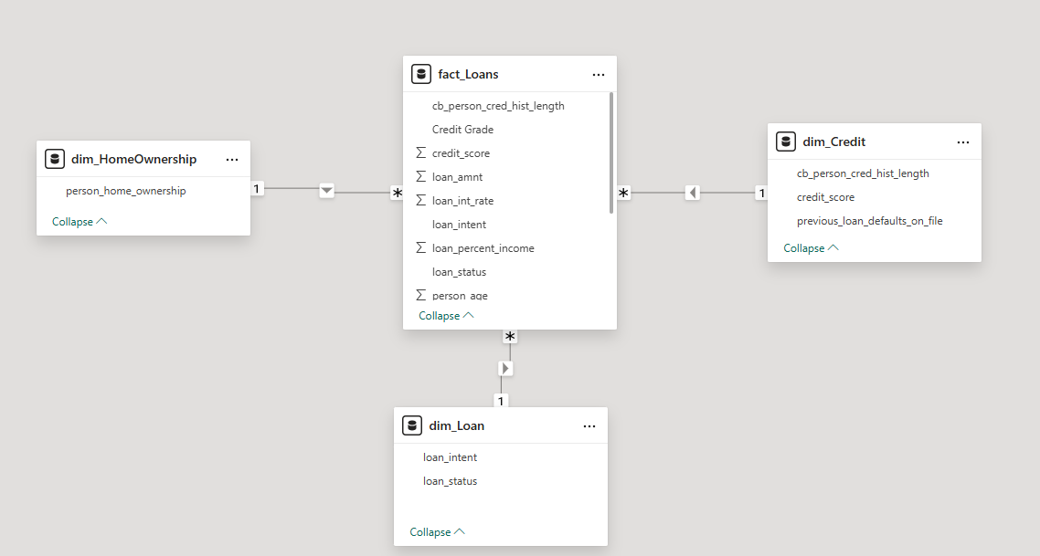

Relationship Management and Cardinality
As shown in the model view, I established One-to-many(1:*) relationships between these dimensions and the fact table. This ensures that descriptive attributes such as education level, gender, or loan purpose can effectively filter the transactional data without creating data redundancy. To maintain strict data integrity and prevent ambiguity in the results, the cross-filter direction for these relationships was set to “Single”, ensuring that filters flow logically from the descriptive dimensions to the fact table.
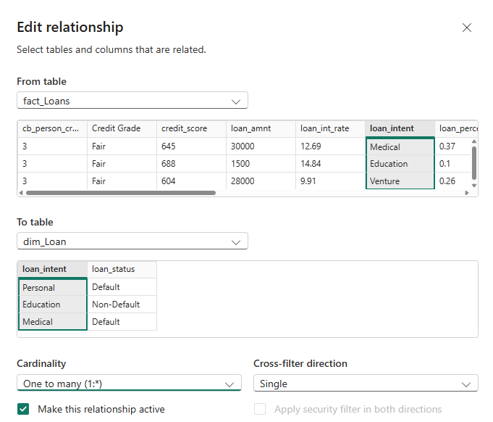

Time Intelligence and Optimization
A dedicated date table was created to support time-based analysis and enable the use of time intelligence functions in Power BI. The date table includes fields such as year, month, quarter, and day , and was generated using DAX. The table allows for consistent time-based filtering and supports calculations such as trends and period comparisons
Although the original dataset does not contain a strong temporal component, the inclusion of a date table enhances the analytical capabilities of the model and aligns with the best practices in Power BI development.
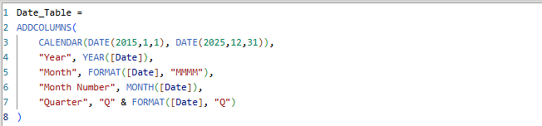
The first few rows found in the Date Table:
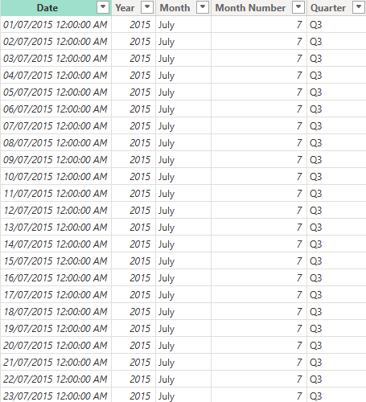

DAX Measures and Calculated Columns

DAX Measures

Total Loan Amount
This measure calculates the total value of all loans issued. It helps assess the overall lending volume of the institution.

Average Loan Amount
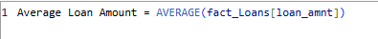
This measure calculates the average loan size, providing insight into typical borrowing behavior.

Total Borrowers
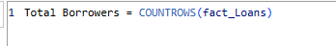
This measure counts the total number of loan applications, representing the number of borrowers analyzed.

Average Interest Rate
This measure calculates the average interest rate applied across all loans, helping evaluate lending conditions.

Default Rate (%)
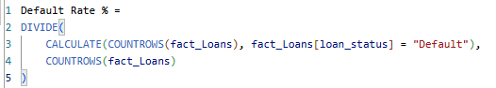
This measure calculates the proportion of loans that have defaulted, providing a key indicator of credit risk.

Approved Loan Rate (%)
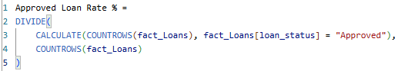
This measure shows the percentage of approved loans, helping evaluate lending success rates.

Average Loan-to-Income Ratio
This measure evaluates how much of a borrower’s income is allocated to loan repayment, indicating financial burden.

High-Risk Loans Count
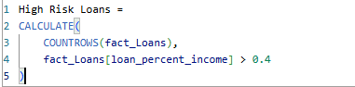
This measure identifies loans where repayment exceeds 40% of income, indicating high financial risk.

Loan Ranking by Amount
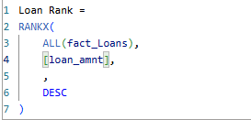
This measure ranks loan values to identify the largest loans issued.

Calculate Columns

Income Band
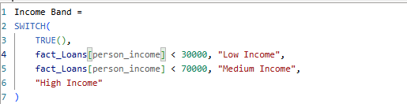
This column categorizes borrowers into income groups to support segmentation analysis.

Risk Category
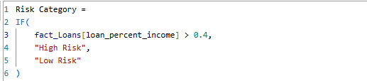
This column classifies loans based on repayment burden, helping identify high-risk borrowers.

Dashboard Design and Visualization
Page 1: Loan Performance Overview
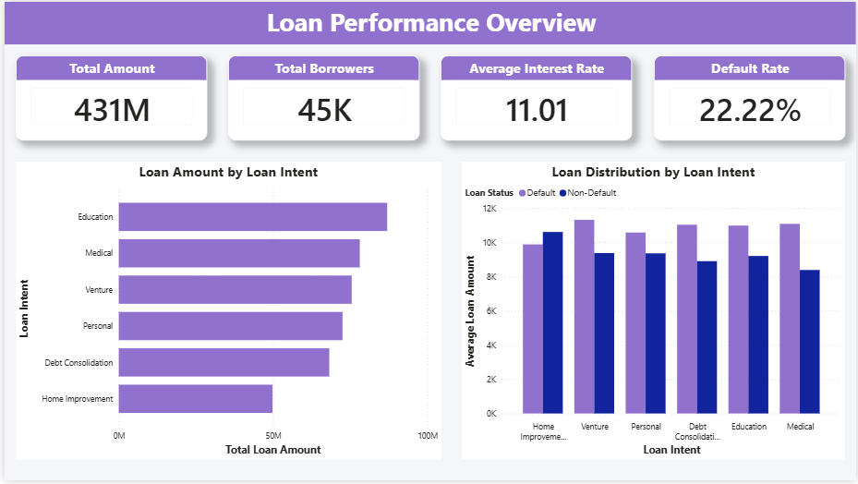
Page 2: Detailed Loan Analysis
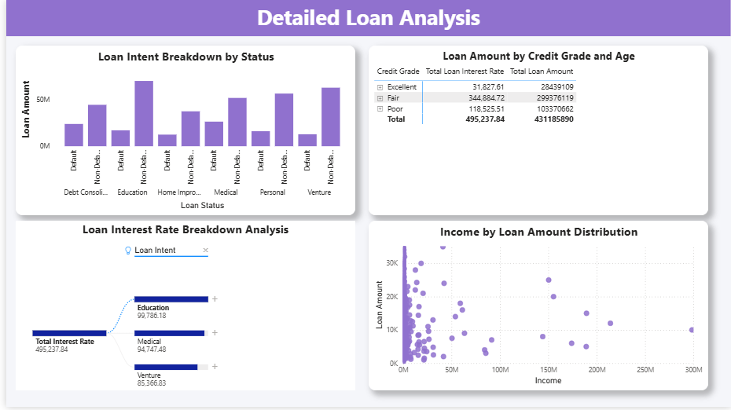

Analytical Insights and Business Recommendations

Analytical Insights
Based on the analysis conducted using the Power BI dashboard, several key insights were identified from the loan dataset.

High Loan Burden Increases Default Risk
It was observed that borrowers with a high loan-to-income ratio (loan_percent_income) are significantly more likely to default on their loans. Loans exceedingly approximately 40% of a borrower’s income show a noticeable increase in default rates, indicating financial strain.

Lower Income Borrowers Exhibit Higher Risk
Borrowers classified under the low-income band tend to have a higher proportion of loan defaults compared to medium- and high-income groups. This suggests that income level is a critical factor in assessing repayment capability.

Certain Loan Intent Categories Carry Higher Risk
Analysis of loan intent categories shows that some types of loans, such as personal or high-risk purposes, are more likely to result in defaults compared to more structured or essential loan categories. This indicates that loan purpose influences repayment behavior.

Credit History Plays a Key Role in Loan Outcomes
Borrowers with shorter credit history lengths and lower credit scores tend to have higher default rates. In contrast, individuals with stronger credit profiles are more likely to have approved and successfully repaid loans.

Home Ownership is Associated with Lower Default Rates
Borrowers who own homes generally exhibit lower default rates compared to renters or individuals with less stable housing situations. This suggests that financial stability and asset ownership contribute positively to loan repayment behavior.

Interest Rates Tend to Be Higher for Riskier Borrowers
Higher interest rates are often associated with borrowers who have lower credit scores or higher loan risk indicators. This reflects risk-based pricing strategies used by financial institutions.

Business Recommendations
Based on the insights derived from the analysis, the following recommendations are proposed to improve loan performance and risk management:

Implement Stricter Controls on High Loan-to-Income Ratios
Financial institutions should introduce stricter approval criteria for borrowers whose loan repayment exceeds a certain percentage of their income (e.g., 40%). This can help reduce the likelihood of default and improve portfolio quality.

Enhance Risk-Based Pricing Strategies
Interest rates should be more closely aligned with borrower risk profiles. Borrowers with lower credit scores or weaker financial positions should be carefully evaluated, and pricing strategies should reflect the associated risk of mitigating potential losses.

Prioritize Lending to Lower-Risk Segments
Lenders should focus on customers with stable income levels, strong credit histories, and home ownership status, as these groups demonstrate lower default rates. Targeting such segments can improve overall loan performance.

Improve Credit Assessment Models
Incorporating additional variables such as credit history length, previous defaults, and income stability into credit scoring models can enhance the accuracy of loan approval decisions.

Offer Financial Education and Support Programs
Providing financial literacy programs for high-risk borrowers may help improve repayment behavior and reduce default rates over time.

GitHub Link: https://github.com/l-kamau/DSA3050-ADVANCED-POWERBI-ANALYSIS

